|  |
| --- |
| Instructional Guide for C347 |

Contents

[Pre-Installation Preparation 1](#_Toc511342006)

[Setting up the workspace 2](#_Toc511342007)

[Installing Android Studio 4](#_Toc511342008)

[Binding the SDK to Android Studio 7](#_Toc511342009)

[Creating your first Android Application 11](#_Toc511342010)

[Creating an Android Virtual Device (AVD) 14](#_Toc511342011)

|  |
| --- |
| Note: This guide can also be obtained from [AY2018-C347 Notebook](onenote:https://myrp.sharepoint.com/sites/AndroidProgramming/AY2018-C347/SiteAssets/AY2018-C347%20Notebook/)  ([Web view](https://myrp.sharepoint.com/sites/AndroidProgramming/AY2018-C347/_layouts/OneNote.aspx?id=%2Fsites%2FAndroidProgramming%2FAY2018-C347%2FSiteAssets%2FAY2018-C347%20Notebook)) |

## Pre-Installation Preparation

You are given 4 files, distributed via thumbdrive during class. Do copy them into a folder.

1. 32-bit JDK installation file
2. 64-bit JDK installation file
3. Android SDK compressed file
4. Android Studio Installation file (no SDK bundled)

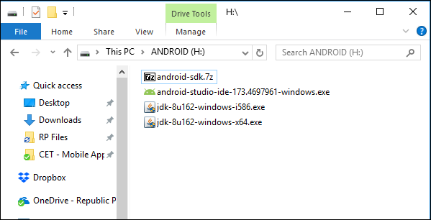

## Setting up the workspace

1. Create a folder for Android related development tools. Example, **Android** in D:\

Computer RP Data (D:) 
File Edit View Tools Help 
Organize 
Include in library 
Share with • 
Search RP DGtG 
New folder 
Favo rites 
Desktop 
Downloads 
Dropbox 
Recent Places 
Google Drive 
OneDrive - Republic 
Name 
E.81N 
Android 
Date modified 
19/11/2014 9:54 PM 
12/4/2017 1:18 PM 
5/12/2015 7:40 PM 
18/10/2016 12:28 
5/12/2015 1:37 PM 
19/4/201610:10 AM 
Type 
File folder 
File folder 
File folder 
File folder 
File folder 
File folder 

1. Extract the Android SDK (android-sdk.7z) to D:\Android

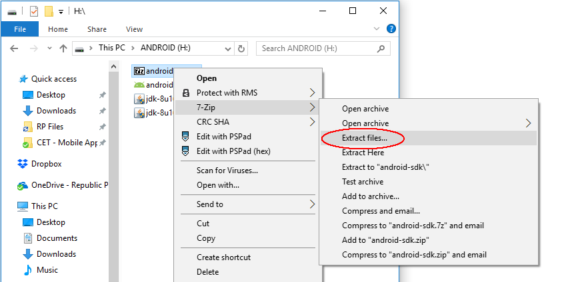

\*Note: If you do not have a zip file extractor installed on your machine, you can get 7-zip, from <http://www.7-zip.org/download.html>

1. Input the appropriate folder location (should be the folder created in Step 1).

冖 冖 冖 冖 冖 凵 冖 一 ㄇ 冖 冖 冖 一 ㄇ 冖 凵 
n 。 囗 
0M ed MOLIS 一 凵 一 
" 1P5 , ℃ 一 0 」 pu 亍 … 
2 we > 0 2 」 0 q 
saweULßed 
apow 2 we > 0 

1. After the extraction of files is completed, you’ll find the files listed as follow

RP Data (D:) Android 
File Edit View Tools Help 
android-sdk 
Search G ndroid-sdk 
Organize 
Include in library 
Share with • 
New folder 
Favo rites 
Desktop 
Downloads 
Dropbox 
Recent Places 
Google Drive 
OneDrive- Republic 
OneDrive for Busine 
SharePoint 
Libraries 
Name 
add-ons 
build-tools 
emulator 
extras 
licenses 
patcher 
platforms 
platform-tools 
skins 
Date modified 
12/4/2017 11:06 AM 
11/4/2017 3:26 PM 
11/4/2017 3:27 PM 
11/4/2017 3:52 PM 
11/4/2017 3:27 PM 
11/4/2017 3:27 PM 
11/4/2017 3:27 PM 
12/4/2017 AM 
11/4/2017 3:27 PM 
11/4/2017 3:30 PM 
Type 
File folder 
File folder 
File folder 
File folder 
File folder 
File folder 
File folder 
File folder 
File folder 
File folder 

## Installing Android Studio

Double click on the file android-studio-ide-162.3871768-windows.exe to start the installation:

|  |  |
| --- | --- |
| Android Studio Setup  Android  Studio  Welcome to Android Studio Setup  Setup will guide you through the installation of Android  It is recommended that pu dose all other applicatons  before starting Setup. This will make it possible to update  relevant system fles without having to reboot your  compu ter.  Click Next to continue. | Click next to proceed |
| Android Studio Setup  Choose which features of Android Studio you want to install.  Check the pu want to install and uncheck the comgu)nents you don't want to  install. Click Next to continue.  Select comgu)nents to install:  Space required: 496.304B  Description  Android Studio  Position your mouse  Android Virtual Device  over a component to  see its description. | Uncheck Android Virtual Device and click next to proceed |
| OD Android Studio Setup  Coriiw*ion  Install L bons  Android Studio Installation Location  The locaton specified must have atleast 500ME of free space.  Click arovvse to customize: | Install the Android Studio to the folder created earlier  (Eg. D:\Android\Android Studio)    Click next to proceed |
| Android Studio Setup  Choose a Start Menu folder for the Android Studio shortcuts.  Select the Start Menu folder in which pu would like to create the program's shortcuts. You  can also enter a name to create a nevv folder.  Android Studiol  7-zp  Accessories  Administratve Tools  Adobe Web Premium CSA  Android Studio  Chris Lovett  Chrome Apps  Dropbox  Fuji Xerox  Games  C] Do not create shortcuts | This creates an entry in the Start Menu. Accept the default value will do.    Click next to proceed |
| OD Android Studio Setup  Please wait while Android Studio is being installed.  Extract: 100%  Shon details | It will take some time to complete the installation. |
| Android Studio Setup  Completing Android Studio Setup  Android Studio has been installed on your computer.  Click Finish to dose Setup.  @StartAndroid Studio  Android  Studio  < Sack  Cancel | Installation is completed.    Click next to start Android Studio |

## Binding the SDK to Android Studio

1. You probably do not have an existing Android Studio or you want to start fresh. Proceed with the below settings.

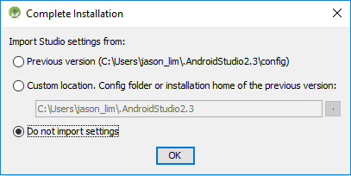

1. At the welcome screen, click next to proceed.

Android Studio Setup Wizard 
Welcome 
Android Studio 
Welcome! This wizard will set up pur development environment for Android Studio. 
Additionally, the wizard will help port existing Android apps into Android Studio 
or create a new Android application project. 
Previous 
Cancel 
Finish 

1. Choose custom as the installation type.

This is because the standard installation will download the SDK from the Internet (this will take some time). We have our own SDK from Step 2, thus need not download the SDK.

Android Studio Setup Wizard 
Install Type 
Choose the type of setup you want for Android Studio: 
O Standard 
Android Studio will be installed with the most common settings and options. 
users. 
Custom 
You can customize installation settings and components installed. 
Previous 
Cancel 
Finish 

1. You could choose any theme as shown below. Click next to proceed.

Android Studio Setup Wizard 
Select UI Theme 
IntelliJ 
Hello W orld 
9 import j avax. swing. * ; 
@import java. awt.* , 
public class HelloWorId 
$1 public HellcRcrId 
JFrame frame 
— new JFrame ( "Hello 
JLabeI Label = new JLabeL ; 
O Darcula 
module Hello World 
HelloWorId java X 
Flimpcrt javax. swing. * 
@impcrt java.awt.*; 
public class HelloRorId 
$1 
public HelloWorId() 
JFrame frame = 
new wc: 
Label. setF 
"Serif" 
3reakpoints 
JLabeI label = new JLabeI ( ) ; 
label. set Font ( new Font 
label . 
Breakpoints 
frame 
frame 
frame 
frame 
- 
Line Breakpoints 
frame . 
frame . 
frame . 
frame 
Previous 
V • Line Breakpoints 
Cancel 
Fon 
Finish 

1. Make sure that the "Performance" is checked or shown as “installed”

Click on the button where the red circle is highlighting to select a new location

Android Studio Setup Wizard 
SDK Components Setup 
Check the components you want to update/install. Click Next to continue. 
Android SDK- (689 MB) 
Android SDK Platform 
59 MB) 
Performance HAXM) (252 
Android Virtual Device— (675 MB) 
Android SDK Location: 
A preconfigured and optimized Android Virtual Device for app 
testing on the emulator. (Recommended) 
Total download size: 850 MB 
Dis space available on drive: 13.1 GS 
Previous 
Cancel 
Finish 

1. A dialog similar to the one below will be shown. Point to the location of the SDK you have extracted to at Step 2

Android SDK 
Select Android SDK install directory 
sdk 
tam 
Android 
andrcid-sdk 
t:] CET - Mobile Apps 
Fyp matters 
homes.soi 
[IP matters 
OrangeHRM 
SIT Tools 
Dr.g drop file into to quickty it in 
Hide path 

1. The selected folder will be reflected, similar to the one below:

Android Studio Setup Wizard 
SDK Components Setup 
Check the components you want to update/install. Click Next to continue. 
Android SDK- (689 MB) 
Android SDK Platform 
API 25: Android 7.11 (Nougat) — (159 MB) 
Performance HAXM) (252 MB) 
Android Virtual Device— (675 MB) 
Android SDK Location: 
A preconfigured and optimized Android Virtual Device for app 
testing on the emulator. (Recommended) 
Total download size: 164 MB 
Disk space available on drive: 1.86 GS 
Lis 
An existing Android SDK was detected. The setup wizard will only download missing or outdated SDK components. 
Previous 
Cancel 
Finish 

1. Next, this is to install the HAXM. Depending on your machine, the support for this varies. Do install this to speed up your Android Emulator if it’s supported.

Depending on the installed RAM on your machine, 2GB is usually the recommended setting.

Android Studio Setup Wizard 
Emulator Settings 
We have detected that your system can run the Android emulator in an accelerated performance mode. 
Please set the maximum amount of RAM available for the Intel@ Hardware Accelerated Execution Manager (HAXM) to use for all x86 
emulator instances. You can change these settings at any time by running the Intel'S HAXM installer. 
Please refer to the Intel(S HAXM Documentation for more information. 
512 Mi8 
2 GiB 
(Recommended) 
RAM allocation: 
3862 Mi8 
2,048 
Previous 
Mi8 
5831 Mi8 
Use recommended size 
Cancel 
Finish 

1. Clicking Finish will finalize the installation process.

## Creating your first Android Application

**Step 1**

You need to prepare a few details:

|  |  |
| --- | --- |
| Application Name | My Application |
| Company Domain | jason\_lim.example.com *(feel free to change this)* |
| Package Name | com.example.jason\_lim.myapplication  *(default value will do)* |
| Project Location | D:\Android\C347Workspace\MyApplication |

\*Note: For the project location, we will save it into a folder as the workspace to capture all the projects for C347. Example: **D:\Android\C347Workspace**

•J Create New Project 
New Project 
Android Studio 
Configure your new project 
Application name: 
Company domain: 
Package name: 
P roject location: 
My Application 
jason_lim.example.com 
com.example.jason_lim.myapplication 
Include C++ support 
Previous 
Cancel 
Finish 

**Step 2**

We could set the minSDK for projects in C347 as API 16, unless stated otherwise.

Create New Project 
Target Android Devices 
Select the form factors your app will run on 
Different platforms may require separate SDKs 
Phone and Tablet 
Minimum SDK 
Wear 
Minimum SDK 
Minimum SDK 
Android Auto 
API 16: Android 4.1 (Jelly Bean) 
Lower API levels target more devices, but have fewer features available. 
By targeting API 16 and later, your app will run on approximately 95.2% 
of the devices 
that are active on the Google Play Store. 
Help me choose 
API 21: Android 5.0 (Lollipop) 
API 21: Android 5.0 (Lollipop) 
Previous 
Cancel 
Finish 

**Step 3**

By default, we will build our app using the simplest template for an Activity.

•J Create New Project 
Add an Activity to Mobile 
Add No Activity 
Fullscreen Activity 
Basic Activity 
Google AdMob Ads Activity 
Bottom Navigation Activity 
Google Maps Activity 
Previous 
Empty Activity 
Login Activity 
Cancel 
Finish 

**Step 4**

We will name the first (and only) Activity in the app here. Default values are shown but feel free to rename them.

•J Create New Project 
Customize the Activity 
Creates a new empty activity 
Activity Name: 
Layout Name: 
Empty Activity 
MainActivity 
Generate Layout File 
activity main 
Backwards Compatibility (AppCompat) 
The name of the activity class to create 
Previous 
Cancel 

**Step 5**

A typical view for a created project

MyAppIication - 
File Edit View 
Navigate 
orkspace\MyAppIication] 
Code Analyze Befactor Build 
[app] - 
Run 1001s VCS Window Help 
app 
MyApplicat,on caapp 
Android 
taapp 
ma n i fests 
main 
lim.myappli 
lim.myappr 
Java 
com 
example • jason_lim 
myapplication 
MainActivit,' 
com.examplejason_lim.myappli 
@ 'b MainActivit,' 
com.examplejason 
com.example.jason 
Gradle Scripts 
activity_main.xml x @ 
MainA ctivity.java 
package com.example.jason_lim.myapplication; 
import 
public class MainActivity extends AppCompatÄctivity 
Tv-err ide 
protected onCreate (Bundle savedInstarn:eState) 
super. cnCreate (savedInstanceState) ; 
setContentView (R. Layout. activi ty main) ; 
Q: Messages Terminal 
6: Android Monitor 
TODO 
14:1 
Q 
Event Log 
Gradle Console 
Gradle build finished in 175 411ms (23 minutes ago) 
CRLF: 
UTF-8: 
Context: < no context> 

## Creating an Android Virtual Device (AVD)

**Step 1** - Launching the AVD Manager

Menu -> Tools -> Android -> AVD Manager, or clicking on the icon on the menu bar

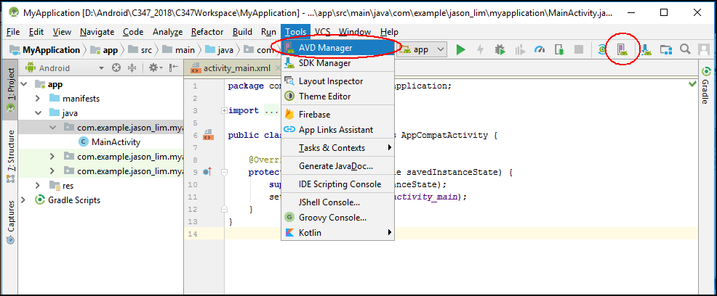

Android Virtual Device Manager 
Your Virtual Devices 
Android Studio 
Virtual devices allow you to test your application without having to 
own the physical devices. 
+ Create Virtual Device... 
To prioritize which devices to test your application on, visit the 
Android Dashboards, where you can get up-to-date information on 
which devices are active in the Android and Google Play ecosystem. 

**Step 2** - Customizing the AVD

Phone, Nexus 5X would suffice.

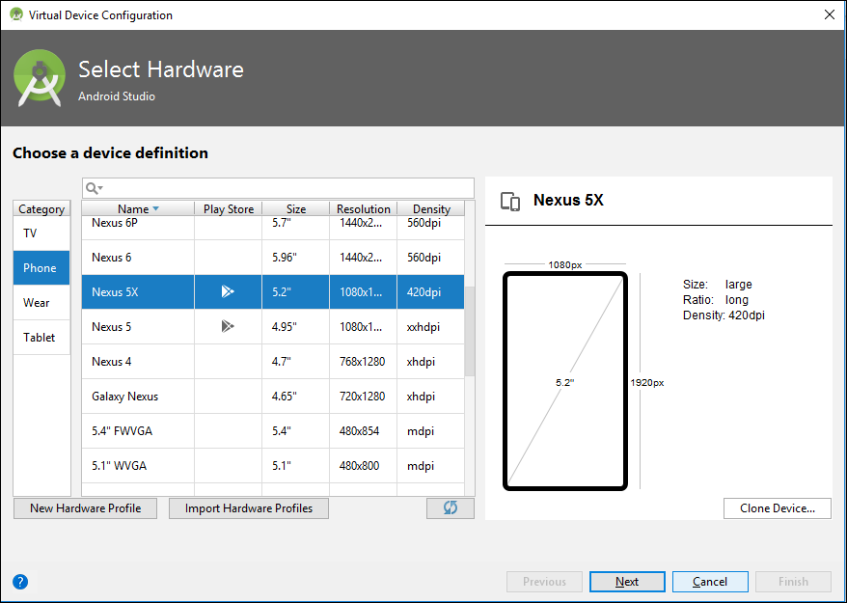

**Step 3** - Choosing the API level for the emulator

This depends on the system image you have installed in your SDK. In C347, we have provided Nougat with Google API (API 25).

If you have installed HAXM (make sure that it has no errors during the installation), you should choose x86. Otherwise, you can use armeabi-7 based image (slower performance)

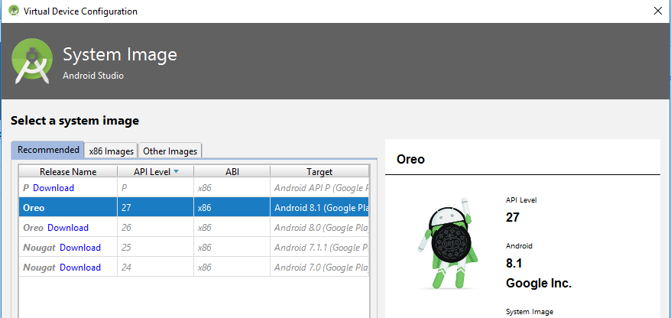

**Step 4** - Other settings

You can accept the default settings for now.

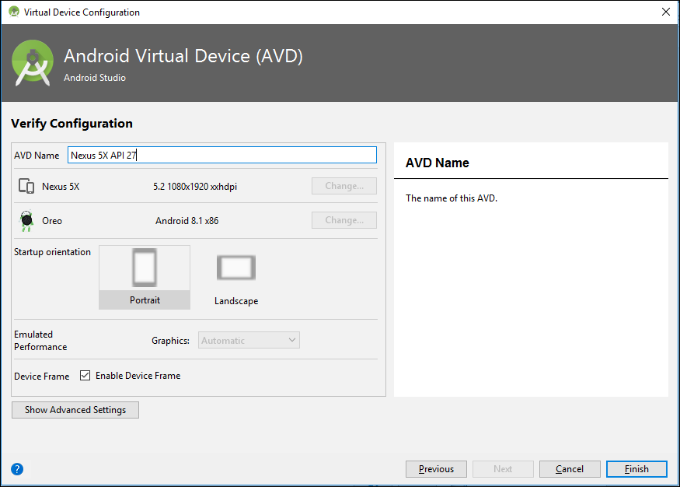

**Step 5** - Verification

Launching the AVD manager, you'll see the AVD has been created.

